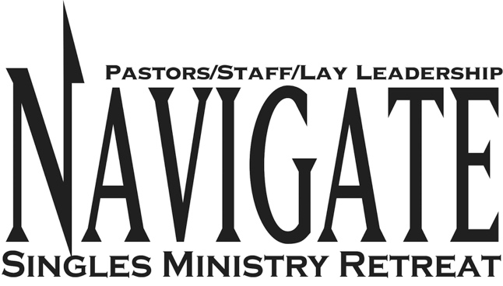

TABLE TOP DISCUSSIONS

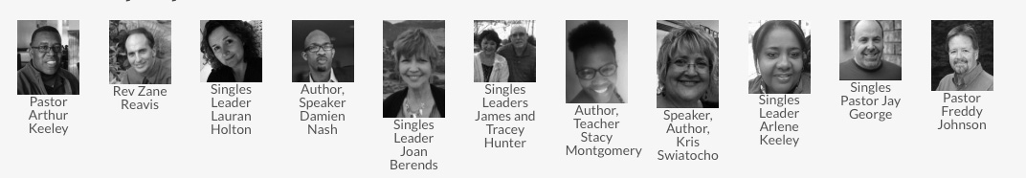

THURSDAY 8:45pm-9:15pm, Table Discussion 1

TABLE #1
Facilitator: Zane Reavis
Topic: The Big Event
Description: Learning how to plan a "big event" in your ministry including prayer, recruiting your team, planning ahead, delegating, advertising and budgeting.

TABLE #2
Facilitator: Freddy Johnson
Topic: 5 ????? Every Singles Ministry Must Asks…
Description: Maybe your Singles Ministry has just begun. Maybe your existing Singles Ministry has lost vision, energy and direction. If either of these describes your ministry, then join Pastor Freddy as he answers the 5 questions that every ministry needs to ask if they are going to be effective in reaching single people in their community.

TABLE #3
Facilitator: Lauran Holton
Topic: Ask a Single Millennial
Description: The truth about Millennials and Gen Z. Who are they? What do they want? How do we reach them?

TABLE #4
Facilitator: Joan Berends
Topic: Community Ministry
Description: Want to host an event outside the church, the community? Want to network churches to help host? Build a team? Come to this table top discussion to learn more.

TABLE #5
Facilitator: Kris Swiatocho
Topic: Starting from Scratch and Itching to Quit
Description: Come and learn the basic principles to successful singles ministry. So, whether you are just starting or have been going a while and need a jump start, this is the discussion for you.

TABLE #6
Facilitator: Jay George
Topic: Promoting Your Singles Ministry-How To’s
Description: Many peoples first look into your ministry happens online even before they walk through door of your church. What do others see when they pull up your ministry online? How can you use a blog, facebook.com, or a website to promote your ministry. Getting the word out on what’s happening in your single’s ministry is paramount! Pastor Jay will discuss ways he uses social media in promoting singles ministry and staying touch with his singles at North Monroe Church.

TABLE #7
Facilitator: Arthur Keeley
Topic: The Journey
Description: The two most important days in your life are the day you were born, and the day you find out why. Learn in this session how to more accurately establish how you personally or your ministry team can determine how to proceed in your spiritual journey. What are the beginning, middle and next steps in your faith walk? This is the beginning of spiritual engagement.

THURSDAY 9:30pm-10:00pm: Breakouts

TABLE #1
Facilitator: James Hunter
Topic: Choosing Well
Description: Choosing the right people who will be able to help you in your singles ministry.

TABLE #2
Facilitator: Freddy Johnson
Topic: Effective Ministry Starts with Passionate Leadership…
Description: Starting a new ministry and running into frustration after frustration? Working in an existing ministry and dealing with challenging people? Having a difficult time getting your pastor or church leadership to buy into the value of Single Adult Ministry? These things, as well as many others, can drain the life out of you and your ministry team. Join Pastor Freddy as he shares his keys to renewing and keeping your passion for God and ministry alive.

TABLE #3:
Facilitator: Arlene Keeley
Topic: Women in Leadership
Description: A discussion on our roles as women in leadership. We will share everything from books we have read that have encouraged you, to a discussion of tools and tips to keep us focused. We will also discuss obstacles that distract us including the enemy’s goal plus solutions to overcome and encourage.

TABLE #4
Facilitator: Tracey Hunter
Topic: Cultivating While Waiting
Description: Becoming the person God intends you to be, including physical, spiritual and relational health.

TABLE #5:
Facilitator: Kris Swiatocho
Topic: Pray for a Mate
Description: 99.9% of all singles want to be married, however, not all will be married due to fear, the past, present day issues, concerns over blending families, children issues, financial, low self-esteem and so forth. Pray for a Mate is a new ministry tool where you meet once a month for 2 hours to pray. Prayer includes praying through our fears and concerns, asking the Holy Spirit to bring to the surface where we need to change so we can become the right mate, etc. While some might get married, the prayer group’s main focus in healing and restoration. Go to www.PrayforaMate.com for more information. The table top discussion will include how you can start one in your church.

TABLE #6
Facilitator: Jay George
Topic: Promoting Your Singles Ministry-How To’s
Description: Many peoples first look into your ministry happens online even before they walk through door of your church. What do others see when they pull up your ministry online? How can you use a blog, Facebook, or a website to promote your ministry. Getting the word out on what’s happening in your single’s ministry is paramount! Pastor Jay will discuss ways he uses social media in promoting singles ministry and staying touch with his singles at North Monroe Church.

TABLE #7:
Facilitator: Arthur Keeley
Topic: The Destination
Description: The Christian Journey is hopeless without a clear understanding of our destination. This session will outline three elements of our personalities that block us from moving forward in our Christian Journey. Most believers miss the opportunity to reach the highest heights of the ministries that could be available to us because of the limitations we put on ourselves. If you want to get people involved in ministry, you have to see the end from the beginning.

FRIDAY 9:15am-9:45am: Table Discussion 1

TABLE #1
Facilitator: Arlene Keeley
Topic: Women in Leadership
Description: A discussion on our roles as women in leadership. We will share everything from books we have read that have encouraged you, to a discussion of tools and tips to keep us focused. We will also discuss obstacles that distract us including the enemy’s goal plus solutions to overcome and encourage.

TABLE #2
Facilitator: Freddy Johnson
Topic: Effective Ministry Starts with Passionate Leadership…
Description: Starting a new ministry and running into frustration after frustration? Working in an existing ministry and dealing with challenging people? Having a difficult time getting your pastor or church leadership to buy into the value of Single Adult Ministry? These things, as well as many others, can drain the life out of you and your ministry team. Join Pastor Freddy as he shares his keys to renewing and keeping your passion for God and ministry alive.

TABLE #3
Facilitator: Lauran Holton
Topic: Ask a Single Millennial
Description: The truth about Millennials and Gen Z. Who are they? What do they want? How do we reach them?

TABLE #4
Facilitator: Stacy Lynn Montgomery
Topic: "How to Be a Good Christian Leader
Description: This discussion will cover ten characteristics that a Christian Leader should possess. Many mistake the title of being a “leader” with “force.” Leadership is not about “forcing” others to do something. Leadership is not about a superior title or position. It is about influencing others. It is a lifestyle. This discussion will introduce the factors that aids in that influence.

TABLE #5:
Facilitator: Kris Swiatocho
Topic: Pray for a Mate
Description: 99.9% of all singles want to be married, however, not all will be married due to fear, the past, present day issues, concerns over blending families, children issues, financial, low self-esteem and so forth. Pray for a Mate is a new ministry tool where you meet once a month for 2 hours to pray. Prayer includes praying through our fears and concerns, asking the Holy Spirit to bring to the surface where we need to change so we can become the right mate, etc. While some might get married, the prayer group’s main focus in healing and restoration. Go to www.PrayforaMate.com for more information. The table top discussion will include how you can start one in your church.

TABLE # 6
Facilitator: Jay George
Topic: Promoting Your Singles Ministry-How To’s
Description: Many peoples first look into your ministry happens online even before they walk through door of your church. What do others see when they pull up your ministry online? How can you use a blog, Facebook, or a website to promote your ministry. Getting the word out on what’s happening in your single’s ministry is paramount! Pastor Jay will discuss ways he uses social media in promoting singles ministry and staying touch with his singles at North Monroe Church.

TABLE #7
Facilitator: Arthur Keeley
Topic: Perception Versus Reality
Description: Perception is more often times than not, absolute truth. However, in the eyes of immature, inexperienced, and less involved church members or attendees what they often see they turn into their own reality. We will never grow as well as we can in our faith when we continually embellish our faith. Truth is the tool that fixes the brokenness we encounter as we continue our journey. Learn in this session how when we are honest with ourselves, we can become who we are destined to be in Christ.

FRIDAY 10:00am-10:30am: Table Discussion 2

TABLE #1
Facilitator: James Hunter
Topic: Choosing Well
Description: Choosing people who will be able to help you in your singles ministry.

TABLE #2
Facilitator: Freddy Johnson
Topic: 5 ????? Every Singles Ministry Must Asks…
Description: Maybe your Singles Ministry has just begun. Maybe your existing Singles Ministry has lost vision, energy and direction. If either of these describes your ministry, then join Pastor Freddy as he answers the 5 questions that every ministry needs to ask if they are going to be effective in reaching single people in their community.

TABLE #3
Facilitator: Tracey Hunter
Topic: Cultivating While Waiting
Description: Becoming the person God intends you to be, including physical, spiritual and relational health.

TABLE #4
Facilitator: Damien Nash
Topic: Teaching Singles How to ACE Their Courtship.
Description: When pastors have read my book they really like this chapter because it gives practical advice on how to develop a healthy courting relationship.

TABLE #5
Facilitator: Kris Swiatocho
Topic: Leadership Development 101
Description: One of the most difficult part of singles ministry is developing good leaders so that your ministry continues to grow. This table top discussion will include how to find good leaders plus developing the leaders you already have including keeping your team together and growing.

TABLE #6
Facilitator: Zane Reavis
Topic: The Big Event
Description: Learning how to plan a "big event" in your ministry including prayer, recruiting your team, planning ahead, delegating, advertising and budgeting.

TABLE #7:
Facilitator: Arthur Keeley
Topic: Seek Change
Description: You have heard… “If nothing changes, nothing changes.” This session will introduce you to 5 key elements that will promote change in any believer! People often don’t change because they don’t have a clear understanding of how to. In order to get members and attendees to grow in their faith, change is a necessity. Learn how to approach change with grace and understanding. Learn more about how to start a ONE+one ministry model for your church!

