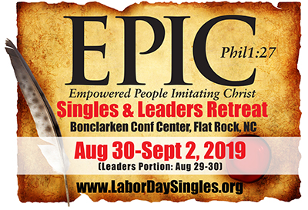
Title/Theme: EPIC Labor Day Singles and Leaders Retreat (Empowered People Imitating Christ)

Location: Bonclarken Conference Center, Flat Rock, NC

Date: August 29-30th, Leader’s portion; August 30-Sept 2nd, 2019 Singles portion

More information: www.LaborDaySingles.org

Leaders: Pastor Freddy Johnson, North Point Church, Columbia, SC; Pastor Jay George, North Monroe Baptist Church, Monroe, LA; Kris Swiatocho, Director of The Singles Network Ministries

Purpose: The Labor Day retreat is in its 41st year in the mountains of NC. In the past 5 years, it has been operated under The Singles Network Ministries, based out of Garner, NC.

This retreat reaches singles adults and its leaders from all over the US (plus the UK/Wales/Albania). Last year we had singles come from 19 different states.

The goal of the retreat is in two parts:
1. To reach singles adults (of all ages and backgrounds) in Christ for salvation, Spiritual growth, encouragement and support through preaching, teaching, small group discussion and prayer. To help them connect to other singles in a safe and healthy way with the goal of building friendships first.

2. To reach leaders, potential leaders and pastors of singles adults to help equip, encourage, support, educate, provide resources and network among other leaders.

A part of our retreat each year we also raise funds for a chosen charity. A charity that ministers to singles adults in various ways. This year’s charity is Seeds of Goodness in Albania. Seeds of Goodness ministers to single adults, singles parents, people with disabilities, the poor and the homeless.

Also, at our retreat we have Lunch and Learn sessions, allowing extended teaching and networking during our lunch time. Plus, we have fun excursions each afternoon, an amazing prayer experience journey on Sunday morning finishing with worship under the stars on Sunday night.

Because we want every single adult to be able to come to our Labor Day retreat, we are thankful to the various sponsors of our retreat. Some of our sponsorship comes in ways of financial donations and some by way of door prizes we can give out or through a silent auction.

If you are led to support this amazing retreat, you can send your tax-deductible donation in check form to:

North Point Church, 532 N Brickyard Rd, Columbia, SC 29223
Please put in the memo line: The Labor Day Retreat (or include a note for it)

If you would like to donate a door prize or item for a silent auction, please contact Missy Honeycutt at 864-270-9901 or singleslabordayexperience@gmail.com.

Thank you for the time in reading this letter and for your prayer support for this year’s retreat.

Blessings
