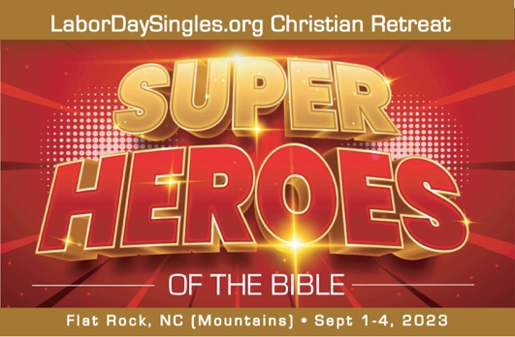
We need your help in supporting the mission
of the national Labor Day Singles
& Leaders Retreat

The event: National Singles Labor Day Singles and Leaders Retreat (44th year)
This year’s theme: Super Heroes of the Bible
Location: Bonclarken Conference Center, Flat Rock, NC
Date: Friday-Monday, Sept 1-4th, 2023
Website: www.LaborDaySingles.org
Because we want every single adult to be able to come to our Labor Day retreat, we are thankful to the various sponsors of our retreat. Some of our sponsorship comes in financial donations and some by way of door prizes and silent auction items. Donations are tax-deductible. You just need to request a receipt with the value of your gift.
Key Leaders/Main Teachers: Pastor Freddy Johnson, North Point Church, Columbia, SC; Kris Swiatocho, Director of The Singles Network Ministries, Hendersonville, NC
The goal of the retreat is two-fold:
- To reach single adults of all ages and backgrounds in Christ for salvation, spiritual growth, encouragement, and support through preaching, teaching, worship, small group discussion, and prayer. To help them connect to other singles safely and healthily and build friendships first.
- To reach leaders, potential leaders, and pastors of single adults to help equip, encourage, support, educate, provide resources, and network among other leaders.
As part of our retreat each year, we also raise funds for a chosen charity that ministers to single adults in various ways. This year’s charity is Crossfire Ministries, a sports evangelistic ministry which shares the Word of God and the Gospel Message of Jesus Christ around the world.
Also, at our retreat, we offer participants Breakfast, Lunch and Learn sessions, which allow for extended teaching and networking, including leadership train g. We plan entertaining excursions each afternoon, worship under the stars on Saturday night, and a fantastic prayer experience journey and discussion on Sunday night to foster relationship-building.
Your financial gifts help us:
• Provide scholarships so those who are low income or have been impacted by Covid can still attend.
• Offset ministry expenses such as office needs, live entertainment, decorations, printing handouts, marketing materials, snacks, etc.

Your physical gifts help us:
• Provide fun door prizes to give away.
• Provide items for our silent auction.
• Provide items such as tablecloths, printing needs, snacks, etc.

We also welcome your prayers!
Tax-deductible financial donation options:
- Donate via Square at https://www.labordaysingles.org/support.h ml. All funds go through our parent ministry: Kris Swiatocho Ministries and are tax-deductible, EIN 83-4513037
- Mail a check payable to Kris Swiatocho Ministries to 638 Spartanburg Hwy, Suite 70-113, Hendersonville, NC 28792; be sure to designate what it’s for in the memo line.
- Set up a monthly donation through www.KrisSwiatochoMinistries.org website. Please designate that it’s for Labor Day weekend.
Other donations: To donate a door prize, silent auction item, decoration, or office supply, please contact our Fundraising Directors, Kate Stewart 919-621-2319 or email us at singleslabordayexperience@gmail.com.
Thank you for the time in reading this letter and for your prayer support for this year’s retreat.
Blessings, The Labor Day Singles Retreat Team

